

**Medicine Dictionary**

**Sprint 2**

**Done By:**

**Jeongyun Lee**

**Ronnel Mattew**

**Marc Visa**

**Eyad Al Hafi**

**Master's Degree in Informatics Engineering**

**Academic course 2020/2021**

**Lleida, November 9th**

Tabla de contenido

The Team: 3

User stories: 4

Sprint Backlog Task and explanation: 7

General Architecture: 11

Diagrams: 12

Use case diagram: 12

Db data model diagram: 14

Entities: 15

Relations 16

Mock up: 17

Economic Viability: 20

Our resources of Income 20

1. Signing contracts: 20

2. Premium users/subscriptions: 22

3. Investments: 22

Our Costs 23

1. Salaries 23

2. Servers 24

3. Advertisements 24

Our Workzone 25

NPV 26

IRR 26

Payback 26

What-if 27

Why we are not going to build admin website? 28

# The Team:

The medicine dictionary team is composed of 4 developers who are responsible for developing applications, creating diagrams and preparing documents. One of the team members will be The scrum master he or she is responsible for organizing and managing the team meeting, documents , tasks and github.

|  |  |
| --- | --- |
| Team members | Role |
| Jeongyun Lee | Developer |
| Ronnel Mattew | Financial expert |
| Marc Visa | Scrum master |
| Eyad Al Hafi | Developer |

# User stories:

For this sprint we added some extra stories that we found that they are mandatory.

User story 1:

As a user I want to create a new account by email or facebook or gmail so that i can use the application with full features.

Acceptance Criteria:

Successful signup.

User story 2:

As a user I want to login to my account by email or facebook or gmail so that i can enter the application with full features.

Acceptance Criteria:

Successful login.

User story 3:

As a user I want to change my account password so that I can remember it better.

Acceptance Criteria:

Successful changing password process.

User story 4:

As a user I want to search for a specific medicine by name or characteristic(color,shape and coe) so that I can add it to my list.

Acceptance Criteria:

Reaching the targeted medicine.

User story 5:

As a user I want to set an for a specific pill alarm so that I can remember the time of taking the pill.

Acceptance Criteria:

Setting the alarm and running in the time successfully.

User story 6:

As a user I want to get notification so that it can follow daily guidelines that are related to my medicines.

Acceptance Criteria:

Getting the appropriate notifications.

User story 7:

As a user I want to get caution reminders so that I can avoid taking two conflicted pills that may affect my health.

Acceptance Criteria:

Warning me when I was in danger.

User story 8:

As a development team we want to find the environment, technologies and tools that we are going to work with so that we can know and learn more about them.

Acceptance Criteria:

Define the environment, used computer language and backend type.

User story 9:

As a development team we want to learn kotlin so that we can start developing our application.

Acceptance Criteria:

Completing the kotlin tutorials.

User story 10:

As a development team we want to learn more about firebase so that we can start developing our application with backend.

Acceptance Criteria:

Completing the firebase tutorials.

User story 11:

As a development team we want to find the best source of data so that we can add it to our database or use it.

Acceptance Criteria:

Defining the data source.

User story 12:

As a development team we want to create a mockup so that we can understand how our application will be.

Acceptance Criteria:

Having all pages that we need in our application that describe the general design, widgets and features.

User story 13:

As a development team we want to create the use case diagram so that we can understand the  application entities and features better.

Acceptance Criteria:

Having a use case diagram that described the entities and features.

User story 14:

As a development team we want to create the db data model diagram so that we can understand and create our backend database easily.

Acceptance Criteria:

Having a db data model diagram that described our database tables.

User story 15:

As a development team we want to create the general architecture diagram so that we can know how we are going to build our application.

Acceptance Criteria:

Having the general architecture done that describes how we are going to build our application.

User story 16:

As a development team we want to create the product backlog and sprint explanation so that we can understand what we are going to do as a whole project and for each sprint.

Acceptance Criteria:

Having the product backlog and sprint explanation done that describes the steps that we are  going to follow.

User story 17:

As a development team we want to fill and study the financial viability so that we can know how much we are going to spend, what we will gain and our business cash flow.

Acceptance Criteria:

Having the  financial viability.

User story 18:

As a scrum master I want to manage the github and daily meetings so that I can organize the sprints processes.

Acceptance Criteria:

Having all the required tasks managed and organized.

User story 19:

As a development team we want to create the powerpoint presentation file so that we can present it at the required date.

Acceptance Criteria:

Having a powerpoint presentation file ready with all the requirements.

SPRINT 2 user stories:

User story 20:

As a user I want to add a medicine from the pill list the app show me every time I search a pill to a kind of pill box, so I can stick to my medical prescription.

Acceptance Criteria: I search a pill, it shows me the list of pills which match my searching conditions, every pill row has a plus button that when it is clicked, that pill is showed in my pill box menu.

User story 21:

As a user I want to be notified of the alarms I set, so that I don’t need to worry about what time I have to take my medicine.

Acceptance Criteria: I am using my mobile phone, it just pops up a notification telling me what I need to know in order to take my medicine.

# Sprint Backlog Task and explanation:

We prepared the sprint backlog and explanation to make it easier to understand what we are going to do and what we are going to follow.

2nd sprint Planning

 Connect to the API to retrieve real data of medicine information in order to show it to the screen in the app.

* Pushing notifications when alarms are set
* Setting alarms and customize them (sleep time)
* Update the use case diagram and explanation
* Update the general architecture system
* Update the product backlog and sprint backlog
* update the financial part excel file
* update the financial part documentation
* pillbox functionality

sprints:

1st sprint:

● Installing program, frameworks:

For developing this application, we are going to use android studio IDE with kotlin language, also we are going to use firebase (Firestore) to store our data.

● UI Mockup:

We did a mockup for our application for the login page by social media and normal way(with username and password), searching page for this page the user will have to choice to do the search the first choice is searching by medicine name and the second one will be by searching by color, shape and the code of the medicine, searching result page this page will give a list of medicines if there are more than medicine for the searching result and the medicine page will include all the information about a special medicine that the user choose it to check.

● study frameworks:

Most of us do not have enough experience with building android application, so we are going to learn more about it by watching android tutorial and firebase tutorials.

● Drawing the charts and diagrams:

We are going to draw the charts and diagrams that will help us to explain more about project like use cases chart and entity diagram

● Financial Factors:

For the first sprint we are going to finish everything related to financial part like cash flow, flow chart and ROI with NPV

● data structure: which data we need to use

We are going to get our data from cima website this website has all data about medicines that we are going to use.

● system connecting:

As we mentioned before we are going to use Firestore to store our data, so the first step will be connecting our application to Firestore.

● Simple sign up, log in, log out:

As an usual app the first page will be login and sign up page.

We are planning to use social media for example Facebook and Google accounts.

Gmail for signing up and logging in.

● Start menu with the logo of the app:

The menu will contain all main parts or features on our app that the user is going to use it.

● Searching engine:

The main feature in our app will be the searching feature we will allow the user to make the search by two ways first one is searching by medicine name and the second one will be searching by color, shape and code of the medicine.

2nd sprint:

* Retrieving real data from PillBox API :

In this second sprint our main goal is to retrieve real data from the API we were using and show it to the user through the same methods we have implemented on the first sprint which is only the search engine feature.

* Setting alarm and pillbox List:

Apart from that, we wish to develop the alarm and pillbox functionalities, so that is to say, let the users set their alarms and save the alarm data in sqlite servers and print the alarms list in the pillbox page so they can see all setted alarms.

* Notification:

Also for this sprint we are planning to start showing random notification for the users. Those notifications will be about daily life health habits and some advice about medicines and health.

* Improving financial part:

In this sprint we are going to add some fields and rows to cash flow and to change all our cash flow to positive and spend our profit in expanding our businesses in new countries.

Furthermore, we expect to explain more deeply about some financial factors, in order to specify more our financial goal for the project. Besides, we need to provide some administration part for the retrieved real data from an external API, although, we decided not to create an admin web project due to some explained reasons on the ADMIN PART REPORT document.

In addition, we count on providing a video demo of our application main functions, in order to show our prototype, since in the last sprint we couldn’t manage to give out.

3rd sprint

●Saving more data about users(survey):

In the 3rd sprint we are planning to allow the user to fill surveys and more data about the user so we can use it in notification.

●Improving notifications:

We are going to improve the notification so every notification will popup for specific users who are interested in it by using survey and user information .

● Improving the GUI:

We are planning to improve the GUI to be better and user friendly so the user can be happy and comfortable while using our app.

● Running the alarms:

In this sprint we are going to start working more with alarm to be able to run and ring to remind the users for their pills.

# General Architecture:

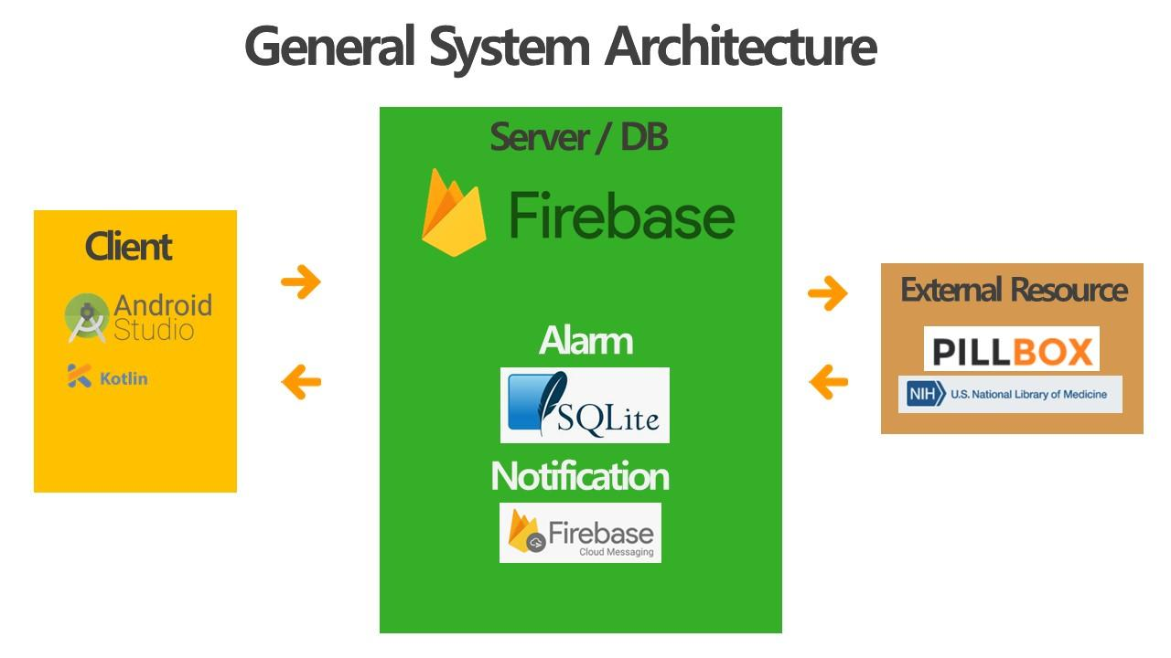

As the previous picture show we updated the general architecture to help us to know what are the environment and tools that we are going to use. The picture shows that we choose to develop by using android studio IDE with kotlin language and we are going to use firebase to store user and notification data, for alarm data we are going to use sqlite so the user can user the alarm feature if the user don’t has internet. The real data are going to be retrieved from an api called pillbox that includes all fields that we need like color, shape and imprint.

# Diagrams:

## Use case diagram:

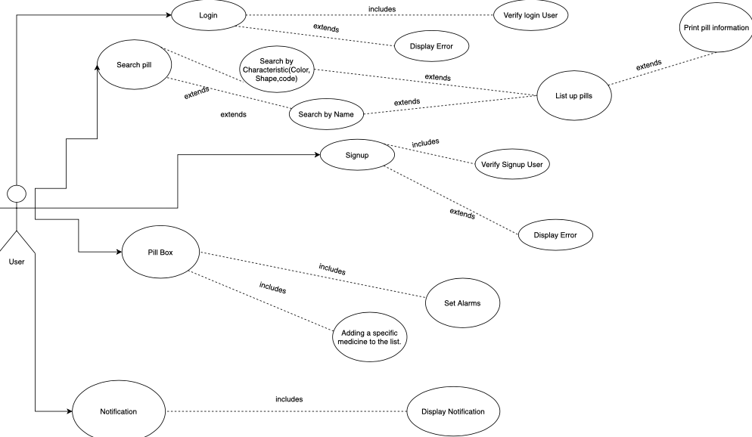

We did some updates in usecase diagram.

There are different functions that play a pivotal role in the Use Case scenario as seen in the Entity relationship diagram, they are:

There are different functions that play a pivotal role in the Use Case scenario as seen in the Entity relationship diagram, they are:

1. **Signup ⇒** In the initial use case, the user would be able to sign up in the application. If the application has verified the user, it would lead the user to the sign in page; else it would display an error. The error would include, if the user does not have a proper internet connection or if the password entered does not consist of special characters.
2. **Login ⇒** In this use case, the user will be able to login to the application with the user’s proper login credentials. But, if the login id or the password is entered incorrectly, the application would display an error.
3. **Search pill ⇒** In this use case, the patients would like to have access to all the available information about any specific medicine. Moreover, this use case includes the following use cases:

* Characteristics: List up different pills according to the characteristics (color,shape,code) given on the search function and the option to add some of these pills to the pill box in order to set an alarm.
* Name: List the pills as per their names.
* Print pill info: This entity would print the information of the pills as per the size,color,shape and ingredients.

Additionally, there are some other use cases which extend the main use case. They are the search by color, the search by shape and the search by code.

1. **Pill box ⇒** In this use case, the patients would like to have all the medicines they take during the day in order to follow the doctor’s prescription.Moreover, this use case includes another use case which is when the user wants to set alarms based on the pills of the pill box, these alarms would act as a reminder to consume those medicines. The user would also have an entity that would include adding the specific medicine to the list inorder to remind them to take the pills.

**Notification** **⇒** In this use case, the application would display the list of pills from the pill box and the Search bar.

## Db data model diagram:

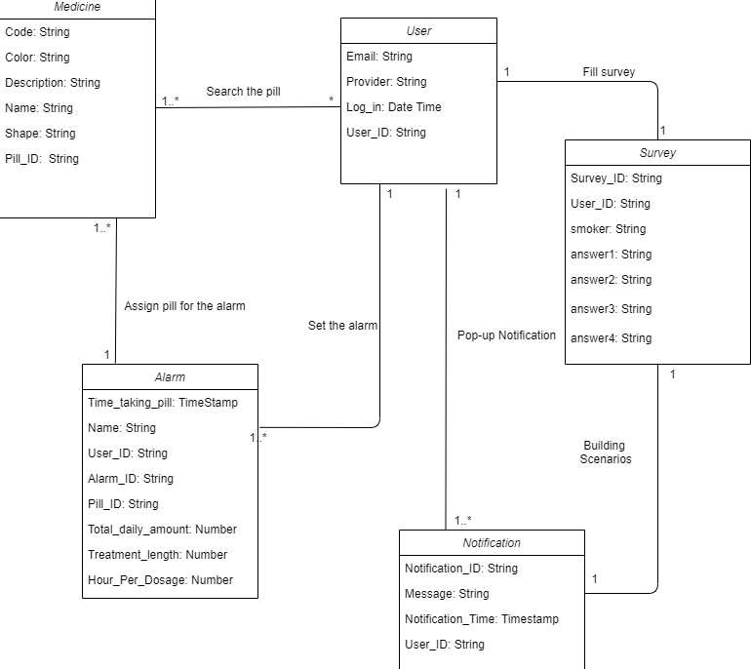

### Entities:

* **Medicine**: As for the medicines, we need to store the code, color, shape and name for the searching function; moreover, a little description of the information pamphlet, which we would like to isolate the side effects since we believe that they are extremely important to take to account. Besides, for data management we would need the Pill_ID for each pill (medicine) as the primary key.
* **User**: Regarding the user authentication and management, we would need to store for each user, their email; the provider, of who has accessed the application, the date when they had signed up, and their last login as well. Furthermore, for data management we would need the User_ID for each user as the primary key.
* **Alarm**: In respect of generating the alarms, we need to store the period of time in which the user has to take the medicine during the day along with the number of days for treating the particular ailment which the user is diagnosed with; a name to title the alarm so the user could have a basic idea of the reason of the alarm; little description of what the alarm is for. Additionally, for data management we would need the User_ID for each user who sets the alarm as a foreign key, the Hour_per_dosage_ID to have knowledge of what is the dose for the particular medicine which needs the alarm, the total_daily_amount of medicines to be taken in a day and the Pill_ID as foreign key. Finally the Alarm_ID as the primary key. Referring to the dosage, we would need to store the amount which the user has to take from the medicine, perhaps the total amount of the medicine in a day just to prevent the user from overdosing, and consequently, the risks of overdosing. In addition, the treatment_length, to remind the user their medical prescription. Furthermore, for data management we would need the Pill_ID for matching a medicine with its pertinent dosage as a foreign key, and the Dose_ID as the primary key.
* **Notification:** A particular user can have multiple notifications that would be displayed with the notification_id along with a caution message and the notification time.
* **Survey:** The survey entity is provided in order to have more information about the users, so a new survey would be for every user with survey_id and a user_id. Whenever a new user signs up in our application, and the user should fill the survey to have more information about our application. There would be a list of options for the users to fill in that would be in the survey entity.

### Relations

* **Search the pill** ( User -- Medicine ): A user might search at least one medicine along their session, whereas a medicine might be searched by many users or none.
* **Set the alarm** ( User -- Alarm ): A user might set many alarms or could be the possibility of none, whereas an alarm might be set only by one user.
* **Assign pill for the alarm** ( Alarm -- Medicine ): An alarm only needs one medicine to assign, so a medicine also goes with one alarm.
* **Fill Survey** (  User -- Survey  )**:** A user would fill a survey form when he/she registers.
* **Building Scenarios** (  Survey -- Notification  ): Once the user fills the survey he would receive the notification based on the survey to which a survey can have a notification.

**Notification** (  User -- Notification  ): A user can have multiple notifications from the application.

# Mock up:

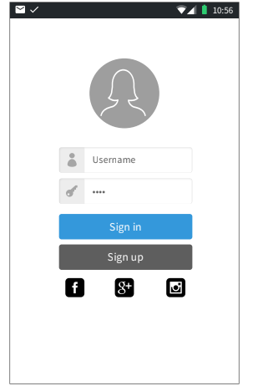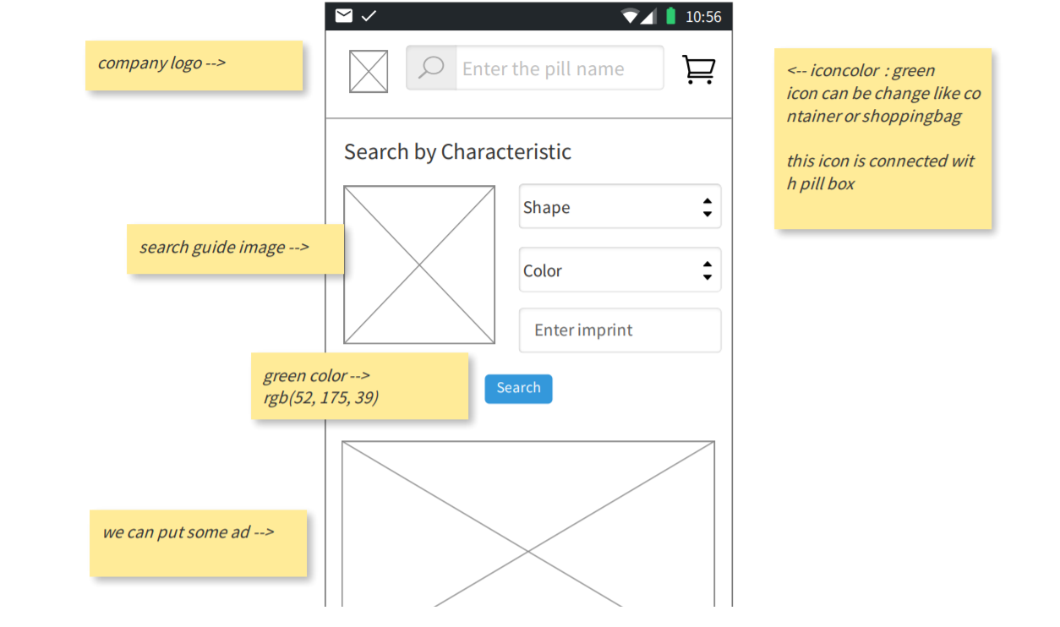

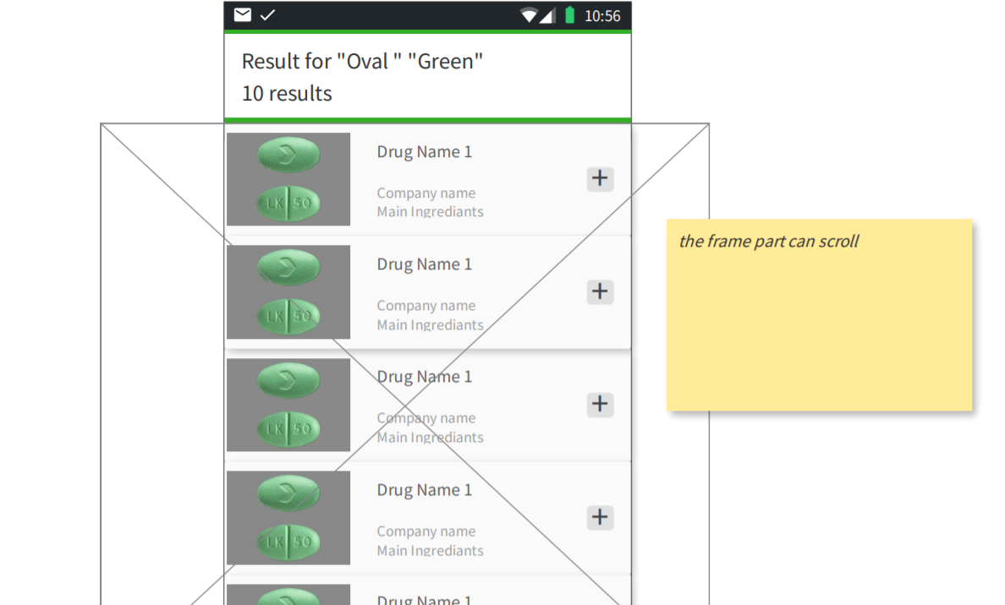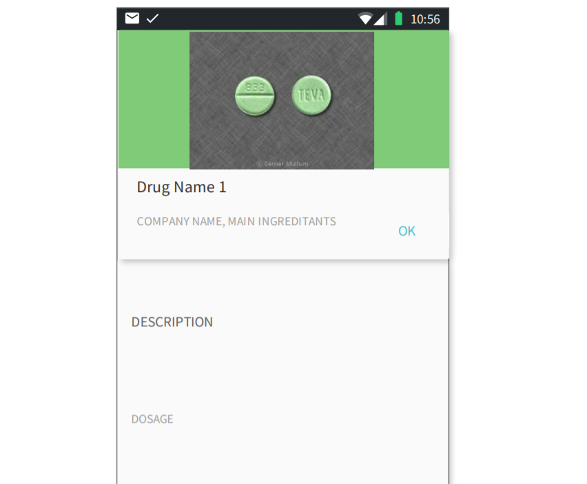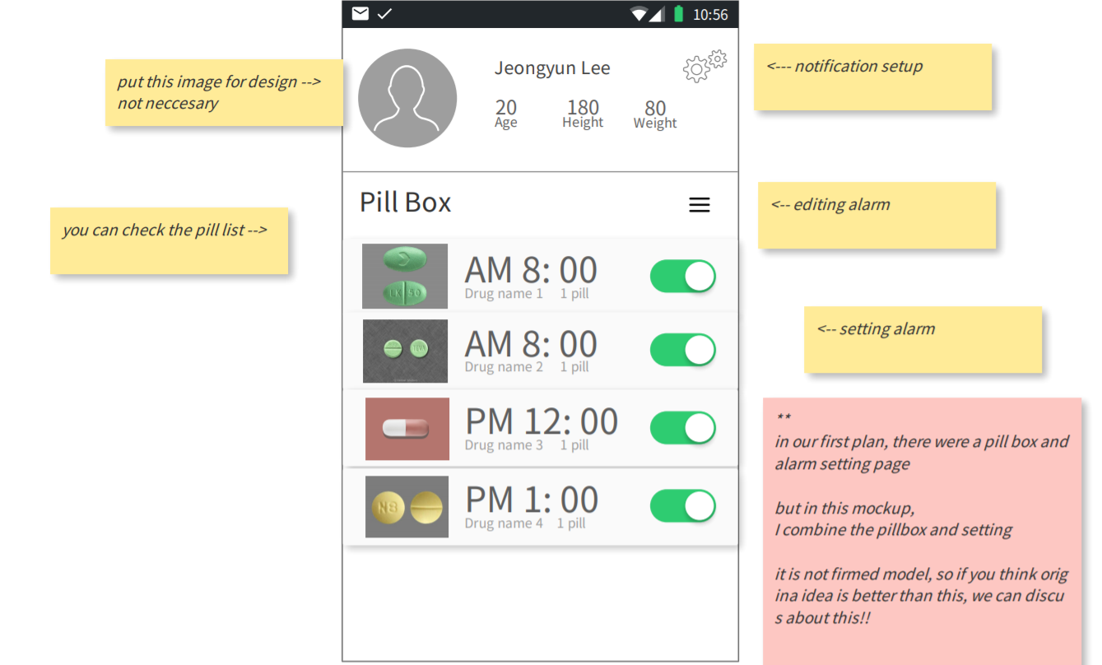

As the previous pictures show we build the mockup to understand how our app is going to be. The app will allow the user to have an account so he or she can make a search for a medicine and add it to the list and set alarms that will remind the users about the pill time. Also our app will include notification features so we can give the user some daily instructions that are related to the user's health.

# Economic Viability:

We did some updates in this part we have been updated the cashflow. We add initial investment and we are going to start for expanding our business in the last year.

A statement of cash flow is a financial document used in conjunction with balance sheets and income statements. Companies will use these financial statements to create a complete financial report.

The below link leads to the Economic Viability:

[S1.- Economic Viablity.xlsx](https://docs.google.com/spreadsheets/d/1IqXhbGNB2awalN9h0mpop3EdCRJC8l8B/edit#gid=606687104)

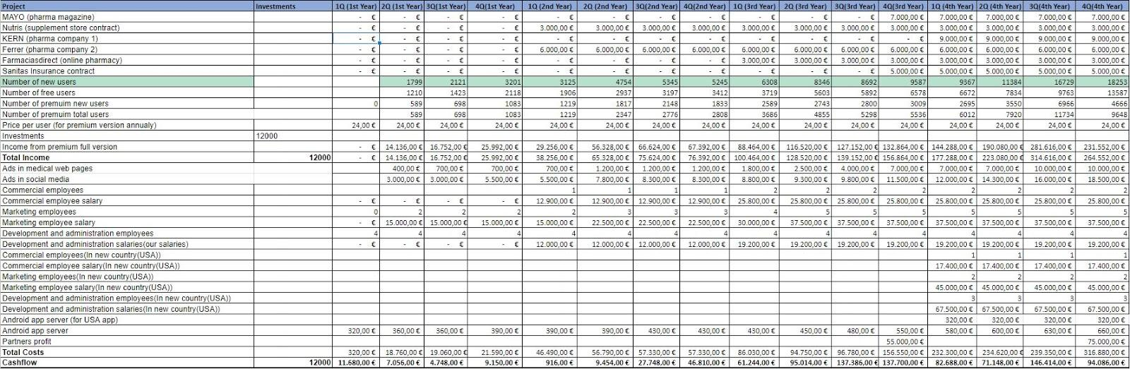

## Our resources of Income

We will have more than one resource for income which are:

1. Signing contracts: One of our main resources of income is signing contracts with pharmacies, pharmacists companies and supplement companies, so we are going to put some ads in our application to get revenue from them.  In the list of contracts in our Incomes (from rows 5 - 10: all those rows are showing the contracts that we are going to login in different fields and with different companies), we will start signing our contracts from the 1st quarter of the 2nd year; this is because we will hire our first commercial employee at the 1st quarter of the 2nd year by then, who would initiate the contracting process with respect to the Incomes. So the signing contract income is related to the number of commercial employees as shown in the previous figure (cash flow table). We will start getting more revenue from contracts when we will hire more commercial employees and also it is related to the number of users who are using our app because when we have more users we can convince more companies to sign with us.

We would sign contracts with the pharma and supplement companies (as mentioned from rows 5 - 10) to display their ads in our application which would be the source of Income, they are:

* MAYO: Mayo is a company with Spanish capital with headquarters in Barcelona and delegation in Madrid that dedicates its main activity to the training of professionals in human and animal health, and the creation of strategic scientific communication solutions for the pharmaceutical sector.  
     
  This company supports the pharmaceutical industry in the development of its marketing actions and creates continuous training, communication and publication projects together with scientific societies and patient associations.  
     
  This company offers many options to shape communication campaigns to reach the target audience with relevant content, at the right time and through the most appropriate channel.   
  This is the link to their website: [MAYO comunicamos salud](http://www.edicionesmayo.es/en/index.php)
* Nutris: Nutris is a Spanish company, based in Madrid, specialized in the healthcare field, including food & food supplements, medical nutrition and sport nutrition. Focused in research, development and manufacturing of nutraceutical products.  
  This is the link to their website: [Ingredients | Healthcare | Nutris Ingredients | Madrid](https://www.nutris.es/)
* KERN: Kern Pharma has a formulary that covers 90% of prescription needs. Its portfolio is made up of more than 230 products in more than 660 different presentations that seek to provide solutions to patients and healthcare professionals.   
  This is the link to their website: [Kern Pharma](https://www.kernpharma.com/es)
* Ferrer: Ferrer is a vertically integrated organization. They offer truly innovative therapeutic solutions in 3 areas, namely: Hospital products, Prescription products and self-care products. In addition, they collaborate in the creation and support of foundations, continuous training of health professionals and are close to patients to detect unmet needs and provide solutions.  
  This is the link to their website: [Ferrer: Inicio](https://ferrer.com/es)
* Farmaciasdirect: Farmaciasdirect was started in 2015, the year in which it was validated for the sale of EFP (advertising pharmaceutical specialties), appearing in the register of pharmacies authorized for online sales, which is operated by the Spanish Agency for Medicines and Health Products.  
    
  Currently, farmaciasdirect.com has established itself as one of the main channels for purchasing pharmacy and parapharmacy products, not only for offering the best prices on the market, but also for offering a quality service and proximity.  
  This is the link to their website: [Tu Farmacia Online y Parafarmacia Online.](https://www.farmaciasdirect.com/)
* Sanitas: With more than 20 years since its creation, the Sanitas Foundation is conceived as an element of health promotion and social transformation through research, the social integration of people with disabilities and the recognition of medical teaching. Supporting inclusive sport, research and health dissemination in Spain, the development of digital tools and the excellence of the best medical professionals, the Sanitas Foundation develops its objectives of social change, equal access to health and well-being of people.   
  This is the link to their website: [Sanitas al cuidado del bienestar de las personas](https://corporativo.sanitas.es/)

1. Premium users/subscriptions: One of our main resources of income is getting revenue from users by creating a premium version of our application that has more features (like setting alarms and getting caution notifications) than the free one. We will price our premium subscription for 2€ monthly (24€ yearly) which is a very fair and cheap price compared to what our app is offering.
2. Investments: We have added an additional column for the initial investment of 12000€ for our company which would be as a startup in order to give a push to the company’s financial growth.

## Our Costs

We will have more than one costs which includes:

1. Salaries: There would be 3 different salaries that will be included which are:
2. *Commercial Employee salary:* The commercial employees are those employees who deal with the relationship and financial factors of the company in getting new contracts for the growth of the company. Moreover, like a Business developer.  
   The salaries of the commercial employees have been kept lower in the 2nd year because of the number of the commercial employees. We would contract more number of employees after the 2nd year when the need arises.  
   This is the link for the average salary of a commercial employee (in Spain): <https://www.glassdoor.es/Sueldos/spain-commercial-manager-sueldo-SRCH_IL.0,5_IN219_KO6,24.htm?countryRedirect=true>
3. *Marketing Employee Salary:* The marketing employees are those employees who monitor market trends, create advertising campaigns, develop pricing strategies and target strategies based on demographic data and work with the company to develop more awareness of what they offer. We will start to hire the marketing team from the 2nd quarter of the 1st year and provide their salaries that would benefit us to achieve users from the 2nd quarter.

This is the link for the average salary of a marketing employee (in Spain): <https://www.glassdoor.es/Sueldos/madrid-marketing-sueldo-SRCH_IL.0,6_IM1030_KO7,16.htm?countryRedirect=true>

1. *Development and Administration salary:* The Development and Administration is a team that runs the process of guiding an organisation toward the achievement of progressive political, economic and social objectives that are authoritatively determined in one manner or the other. In our case, we as a team have decided to work in the development part and develop the application. This team would be responsible for taking important decisions about the various business factors.  
   The Development and Administration team’s salary would also be initiated from the 2nd year with low salary and then we will increase it in the upcoming years. This is because we are parties in this business so we have to invest more on it especially in the first two years to be a successful business in the future.  
    *New country (U.S.A.):* In the cash flow sheet, we see that there are replicated rows that includes the commercial, marketing and the development & administration team.  In the first quarter of the fourth year we will take a decision to expand our business, so in the fourth year we will start preparing to start the business. These rows are added as we plan to start our business in the U.S. and we have included approximate values of salaries to each of them as per the latest reports.  
   The reason to choose the U.S for starting our business is because the salaries there are greater than the salaries in Europe. Hence, it would be a boost in the financial growth of our company.
2. Servers: An app hosting platform can cost around 320€/quarter which would be increased as the development of the application changes/modifies with new/updated features. The cost of the server increases when the number of users increases.
3. Advertisements: We have divided the ad postings on the medical website pages and on social media sites (like Facebook,Instagram and Youtube). For the ad postings, we have invested more on social media platforms than on medical websites. This is because now-a-days, people spend most of their time on social media more than on medical sites. The number of users are related to ads because the more we invest in advertisements the more we will get more new users. As shown in the previous figure, the number of users are increasing while the amount of investment on the advertisements gets increased.

## Our Workzone

We have decided to create a virtual office and work as an online company as it would lead to cost reduction and reduce other expenses that includes the different equipment, electricity, etc.

In addition, our application is an online service so there would be online contact with our customers to solve their queries.

We have decided to assign the following post:

*Chief Executive Officer*: Yoon

*Chief Technology Officer*: Eyad

*Chief Marketing Officer*: Marc

*Chief Financial Officer*: Ronnel

In the workforce, we as a team ourselves have decided to build and develop the application. We are trying to follow the American system such that every employee has their own equipment to work on. It will be better to reduce the cost. Also our workforce will increase every year or maybe quarter because we will get new users so we need more employees to manage and organize the business.

Below gives the description of each of the tabs mentioned in the economic viability:

## NPV

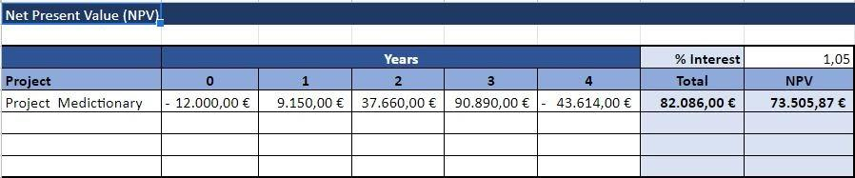

In the NPV sheet, the values for each year have been received on the basis of the cash flow sheet with respect to every single quarter in every year. The first year of the NPV sheet value would be the cash flow of the last quarter of the first year in the cashflow. The values of the remaining years in the NPV sheet would be achieved by calculating the total of the income and cost subtraction quarterly and then we implement the NPV formula.  
*Note:* We have added our investment as the initial investment in the 0th column (-12000 €)

## IRR

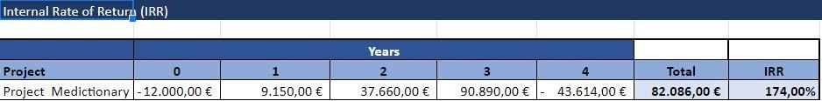

The calculation in the NPV sheet yearly values are the same in the IRR sheet as well and then we implement the IRR formula.

## Payback

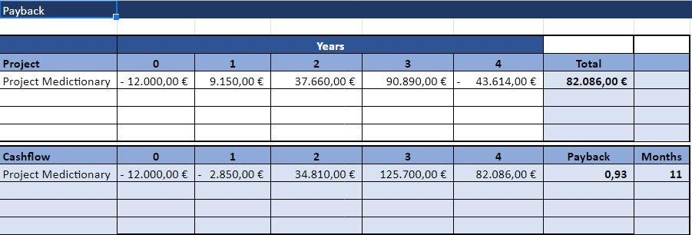

For the Payback, the values are achieved by summing up the previous year’s value with the IRR and NPV and then we implement the Payback formula.

## What-if

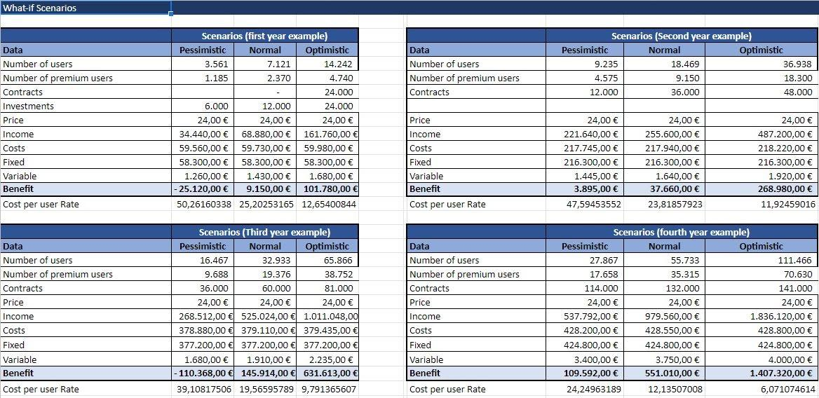

In the What-if scenario, we will see the 3 different users and the estimation of their values:

*Pessimistic*: The values in this column have been achieved on the basis of the Normal users. These values should be half of the Normal users (50%). We tried to assume the worst case scenario and we found that when we decrease it by 50% it will be the worst case.

*Normal*: The values in this column have been achieved on the basis of the total number of users from the cash flow sheet for a particular year. For example, in the first year example, we have included a sum of the total number of users of all the quarters of the 1st year. Also the cost and income had been taken from the cash flow sheet.

*Note:* The ‘Fixed’ are the fixed costs that will never be changed in our table that includes salaries and advertisement.The variable one that includes the server cost (Firebase).

*Optimistic*: The values in this column have been achieved on the basis of Normal users. These values should be double or more than the Normal users (100%). We tried to assume the best case scenario and we found that when we increase it by 100% it will be the best case.

Cost per user rate has also been included in the sheet. We achieve these values while calculating the cost per the number of premium users.

We added the cost per user rate row to calculate the percentage of losing and gaining money in the pessimistic and optimistic. As per the above figure, there is a change in the percentage every year. For example, in the first year, we will lose around 50% if we faced pessimistic scenario and we will gain around 12.6% if we face an optimistic scenario. It will be the same idea with the other years but with different rates.

# Why we are not going to build admin website?

Firstly, we tried to connect our project application to the CIMA API which was offered by the Spanish government. However, that API wasn’t as good as we expected since it doesn’t contain the data that we need like shape and color. So, in order to add up our way to store the medicine information (the same data fields as the firestore database in sprint 1) and the external API used, we decided to go for the pillbox API which is maintained by the American government. Moreover, in order to connect and consume that API we agreed to use, thanks to professor Jordi advice, the Retrofit Android library.

Taking into account all mentioned before, we debated the option we would have of doing a web project as an administration part of the app data and we have considered that we don’t need to create it since the pillbox API is supervised by professionals of medicine, pharmacy, etc and updated by the American government and all data is already reviewed so no need to review it again since we are not expert in that field.Also we think that firebase is more than enough to manage our other data.